

**Faculty of Engineering & Applied Science**

**Experiment Name:** **Integrating Sensors to a Microcontroller Board**

**Experiment date: 09/21/2022**

**Group Number*: 4***

**Section CRN:**

**Course Instructor: *Ramiro Liscano***

**Lab TA:*****Sifatul Mostafi***

| **Student Name** | **Student Id** |
| --- | --- |
| Preet Patel | *100708239* |
| Tiwaloluwa Ojo | *100700622* |
| Waleed El Alawi | *100764573* |

## **Learning Objectives**

The objective of this lab was to get introduced to working with the Raspberry Pi 3. We learned how to set up the Raspberry Pi OS image setup onto the Raspberry Pi 3, and we also learned how to set up the network on the Raspberry Pi 3 so it can be connected with a host machine using SSH from Linux and Putty (also SSH) from windows. We gained experience working with Linux and the Raspberry Pi 3, we learned how to compile code to a x86-64 executable file and transfer the file between a host machine and the Raspberry Pi 3.

## **Deliverables:**

Connecting windows localhost with Raspberry Pi 3:

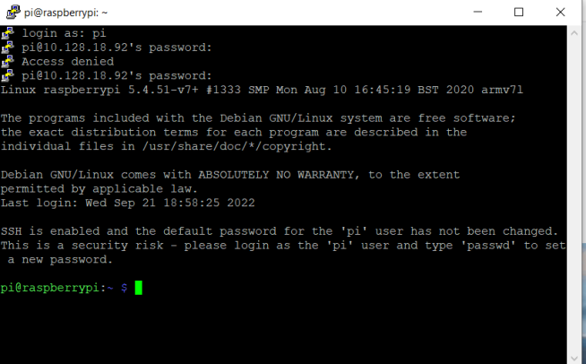

IP address used for putty connection:



Checking Raspberry Version:

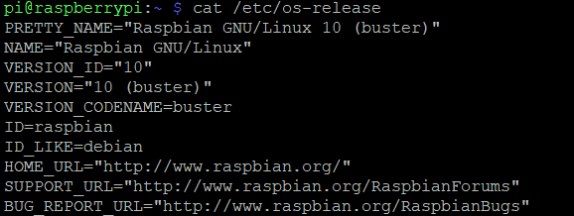

Checking Raspberry Pi CPU Version:

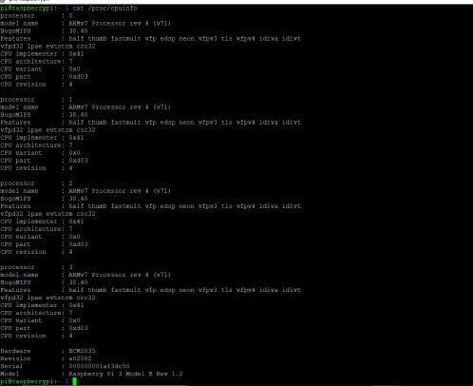



Download the toolchain on Ubuntu and adding path to the environment:

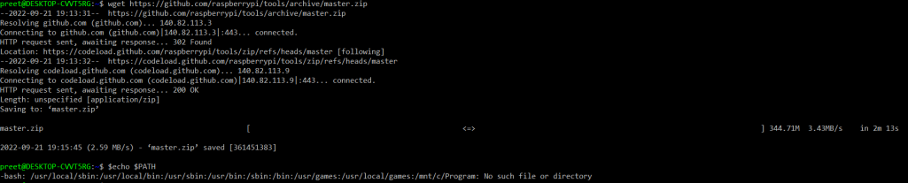

Creating Hello.c file and installing arm toolchain for compiling Hello.c:

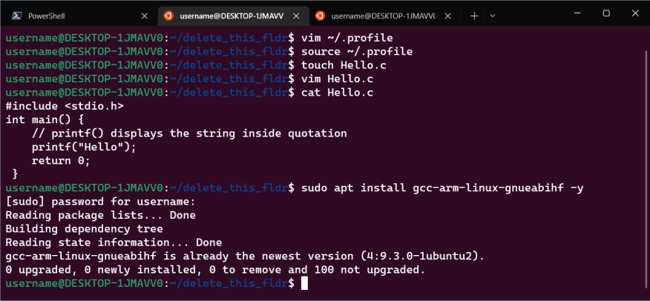

Updating profile path variable

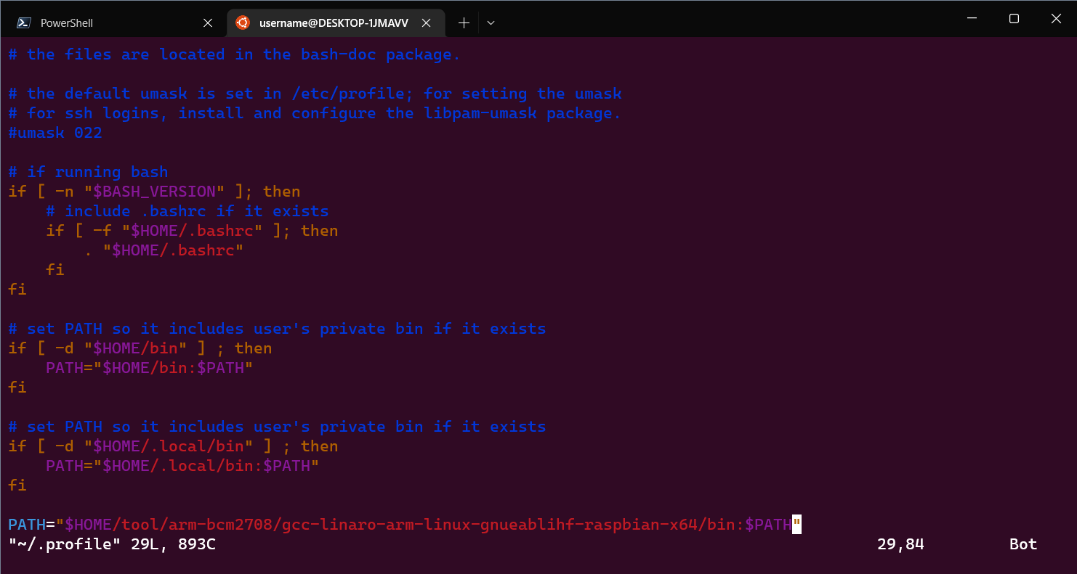

Compiling Hello.c:

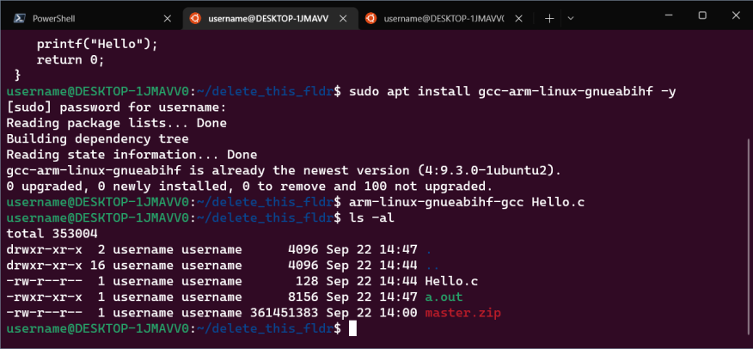

Command executed to send a.out file to Pi: “scp a.out pi@192.168.2.76:home/pi/Documents”:

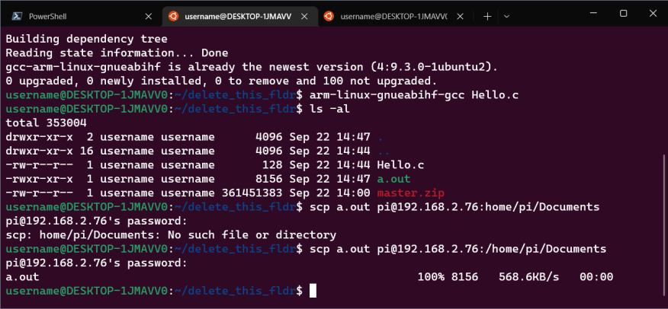

Command to ssh to the Pi: “ssh pi@192.168.2.76”:

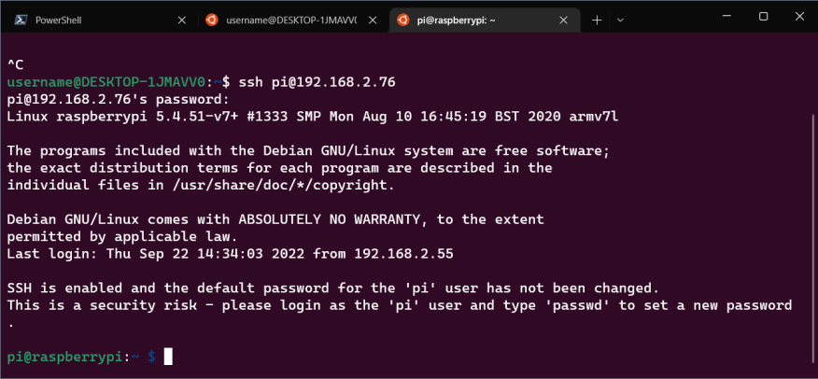

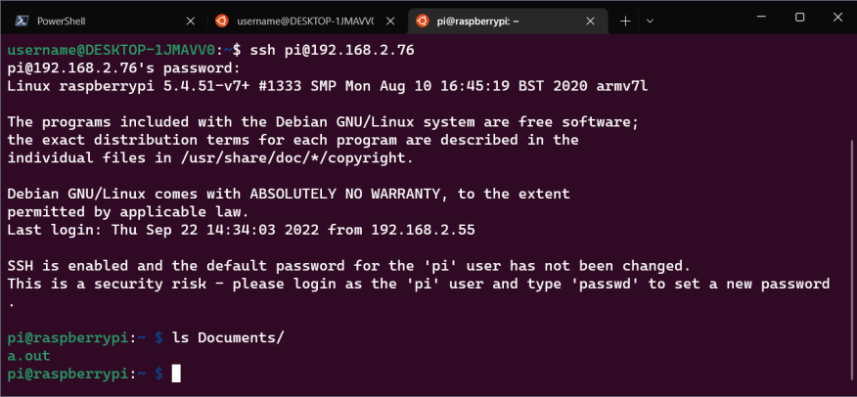

**Please describe the difficulties you run into and explain how you tackle the problems and resolve them**

We had difficulties connecting with the Raspberry Pi through SSH using Putty. We kept running into a “connection refused” error. We hypothesized we had used the wrong IP address. We used Google to search for a solution in which we found out that one of the possible causes of the problem could be the Raspberry Pi 3 configuration. So we checked the configuration of the Raspberry Pi from preferences and saw that the settings for SSH, and other important network settings were turned off. We turned on those settings and rebooted the Raspberry Pi which then allowed us to connect to it using Putty from our windows environment. We also tried connecting to it from our Ubuntu VM environment which allowed us to directly connect to the Raspberry Pi using SSH.

